PROGRAMMING WITH PYTHON SUBJECT CODE : 202044504

DEPARTMENT OF INFORMATION TECHNOLOGY
SEMESTER 5

NAME :KAPATEL KASHAK
ENROLLMENT NO. : 12402080601060 BATCH :IT_A 1C8 ACADEMIC YEAR : 2026-27

Github Link :

ASSIGNMENT-1
PROBLEM STATEMENT 1: You are given records of students in the form enrollment, name, semester, CPI and a list of subject marks. Build a program that stores the records using lists, tuples and dictionaries. For each semester, print the top K students by CPI. If CPI is the same, prefer the student with higher average marks; if still tied, prefer lexicographically smaller enrollment number. Also print the subject-wise topper for every subject code.

CODE :
def main():
n, k, m = map(int, input().split()) if not (1 <= n <= 100000):
raise ValueError("Number of students must be between 1 and 100000.")

if not (1 <= k <= 50):
raise ValueError("K must be between 1 and 50.")

if not (1 <= m <= 12):
raise ValueError("Number of subjects must be between 1 and 12.") semester_students = {}
subject_toppers = {} for i in range(1, m + 1):
subject_toppers[f"S{i}"] = (-1, [])
for _ in range(n):
data = input().split()

enrollment = data[0] name = data[1] semester = int(data[2]) cpi = float(data[3])
marks = list(map(int, data[4:])) if len(marks) != m:
raise ValueError(
f"{enrollment} must have exactly {m} subject marks."
)

if any(mark < 0 or mark > 100 for mark in marks):
raise ValueError("Marks must be between 0 and 100.")

if not (1 <= semester <= 8):
raise ValueError("Semester must be between 1 and 8.")

if not (0.0 <= cpi <= 10.0):
raise ValueError("CPI must be between 0.0 and 10.0.") average_marks = sum(marks) / m
student = ( enrollment, name,
cpi, average_marks, marks
)

if semester not in semester_students: semester_students[semester] = []
semester_students[semester].append(student
) for i, mark in enumerate(marks, start=1): subject = f"S{i}"
highest_mark, toppers = subject_toppers[subject] if mark > highest_mark:
subject_toppers[subject] = (mark, [enrollment])
elif mark == highest_mark: toppers.append(enrollment)
for semester in sorted(semester_students): students = semester_students[semester] students.sort(
key=lambda student: (
-student[2],
-student[3], student[0]
)
)
top_students = students[:k]

enrollments = [student[0] for student in top_students] print(f"Semester {semester}:", *enrollments)
for i in range(1, m + 1): subject = f"S{i}"
highest_mark, toppers = subject_toppers[subject] toppers.sort()
print(f"{subject}:",
*toppers) if name== "main": main()

OUTPUT:
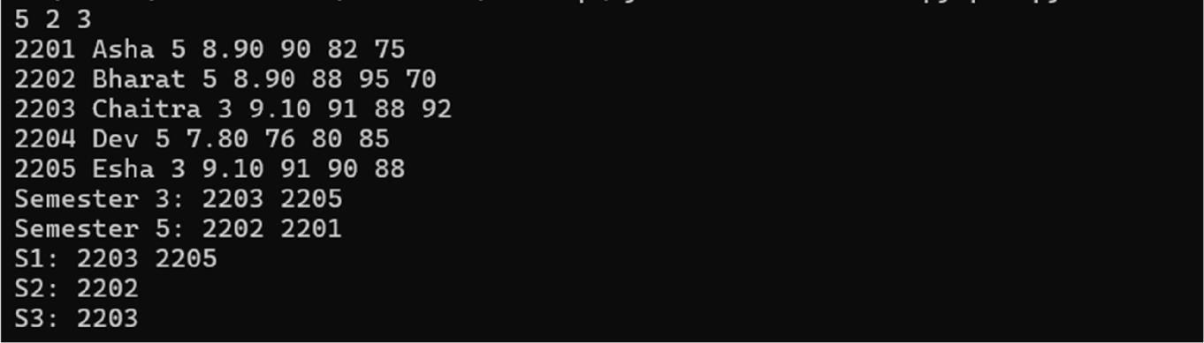

PROBLEM STATEMENT 2: Given n candidate passwords, classify each as STRONG, WEAK_LENGTH, WEAK_PATTERN or COMPROMISED. A strong password must contain at least one lowercase letter, uppercase letter, digit and one special symbol from $#@. Its length must be between 6 and 12. It must not contain any dictionary word from a banned list as a contiguous substring, ignoring case. It must also not contain the same character more than 3 times consecutively.

CODE :
import re
class TrieNode: def init(self):
self.children = {} self.is_end = False

class Trie:
def init(self):
self.root = TrieNode() def insert(self, word):
node = self.root
for char in word.lower():
if char not in node.children: node.children[char] = TrieNode()

node = node.children[char] node.is_end = True
def contains_banned_word(self, password): password = password.lower()
for start in range(len(password)): node = self.root
for end in range(start, len(password)): char = password[end]
if char not in node.children: break
node = node.children[char] if node.is_end:

return Truereturn False

def has_required_characters(password): has_lower = False
has_upper = False has_digit = False has_special = False
for char in password: if char.islower():
has_lower = True elif char.isupper():
has_upper = True elif char.isdigit():
has_digit = True elif char in "$#@":
has_special = True

return has_lower and has_upper and has_digit and has_special def has_repeated_character(password):
if not password: return False

consecutive_count = 1
for i in range(1, len(password)):
if password[i] == password[i - 1]: consecutive_count += 1
if consecutive_count > 3: return True
else:
consecutive_count = 1
return False
def classify_password(password, banned_trie): if len(password) < 6 or len(password) > 12:
return "WEAK_LENGTH"

if not has_required_characters(password): return "WEAK_PATTERN"

if has_repeated_character(password): return "WEAK_PATTERN"

if banned_trie.contains_banned_word(password): return "COMPROMISED"
return "STRONG" def
main():
b = int(input().strip())
if not (1 <= b <= 10000):
raise ValueError("Number of banned words must be between 1 and 10000.") banned_trie = Trie()
for _ in range(b):
word = input().strip() if word:
banned_trie.insert(word) n = int(input().strip())
if not (1 <= n <= 100000):
raise ValueError("Number of passwords must be between 1 and 100000.")

for index in range(1, n + 1): password = input().rstrip("\n")
result = classify_password(password, banned_trie) print(f"{index}: {result}")

if name == "main": main()

OUTPUT:
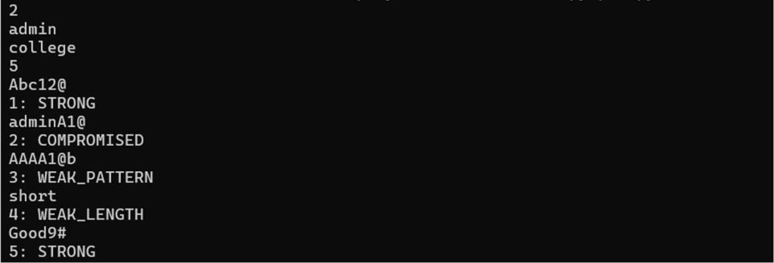

PROBLEM STATEMENT 3: Implement a recursive expression evaluator for integer expressions containing non-negative integers, +, -, *, parentheses and variable references. Each variable may be defined by another expression. Detect cyclic variable dependencies and report CYCLE. Use memoization so that repeated variable evaluations are not recomputed.

CODE :
import re
class ExpressionEngine: def init(self, variables):
self.variables = variables
self.memo = {} self.visiting = set()
self.variable_pattern = re.compile(r"^[A-Za-z_][A-Za-z0-9_]*$") def tokenize(self, expression):
tokens = [] i = 0
while i < len(expression):

if
expression[i].isspace()
: i += 1
continue

if expression[i].isdigit(): j = i
while j < len(expression) and expression[j].isdigit(): j += 1
tokens.append(("NUMBER", expression[i:j])) i = j
continue

if expression[i].isalpha() or expression[i] == "_": j = i
while (
j < len(expression)
and (expression[j].isalnum() or expression[j] == "_")
):

j += 1
tokens.append(("VARIABLE", expression[i:j]))i = j continue

if expression[i] in "+-*()": tokens.append((expression[i], expression[i])) i += 1
continue

raise ValueError("Invalid character in expression.") return tokens
def evaluate_variable(self, name):

if name in self.memo: return self.memo[name]

if name not in self.variables:
raise ValueError("Unknown variable.")

if name in self.visiting:
raise RuntimeError("CYCLE") self.visiting.add(name)
try:
tokens = self.tokenize(self.variables[name])
value, position = self.parse_expression(tokens, 0) if position != len(tokens):
raise ValueError("Invalid expression.") self.memo[name] = value
return value
finally:
self.visiting.remove(name)

def parse_expression(self, tokens, position):

value, position = self.parse_term(tokens, position) while position < len(tokens):

operator = tokens[position][0] if operator not in ("+", "-"):
break position += 1
right_value, position = self.parse_term(tokens, position)

if operator == "+": value += right_value
else:
value -= right_value return value, position
def parse_term(self, tokens, position):

value, position = self.parse_factor(tokens, position) while position < len(tokens):
operator = tokens[position][0]

if operator != "*": break
position += 1

right_value, position = self.parse_factor(tokens, position) value *= right_value
return value, position
def parse_factor(self, tokens, position): if position >= len(tokens):
raise ValueError("Invalid expression.") token_type, token_value = tokens[position] if token_type == "NUMBER":

return int(token_value), position + 1 if token_type == "VARIABLE":
if token_value not in self.variables:
raise ValueError("Unknown variable.") value = self.evaluate_variable(token_value) return value, position + 1
if token_type == "(":

value, position = self.parse_expression( tokens,
position + 1
)
if (
position >= len(tokens)
or tokens[position][0] != ")"
):
raise ValueError("Missing closing parenthesis.")
return value, position + 1
raise ValueError("Invalid expression.") def evaluate(self, expression):
tokens = self.tokenize(expression) if not tokens:
raise ValueError("Empty expression.")
value, position = self.parse_expression(tokens, 0)

if position != len(tokens):
raise ValueError("Invalid expression.") return value
def main():
v = int(input().strip())

if v < 1:
raise ValueError("Number of variables must be at least 1.") variables = {}
for _ in range(v):

line = input().strip() if "=" not in line:
print("INVALID") return
name, expression = line.split("=", 1) name = name.strip()
expression = expression.strip()
if not re.match(r"^[A-Za-z_][A-Za-z0-9_]*$", name): print("INVALID")
return
if not expression: print("INVALID") return
variables[name] = expression final_expression = input().strip()
try:
engine = ExpressionEngine(variables) result = engine.evaluate(final_expression) print(result)
except RuntimeError as error: if str(error) == "CYCLE":
print("CYCLE") else:
print("INVALID")
except (ValueError, RecursionError): print("INVALID")

if name == " main ": main()

OUTPUT:
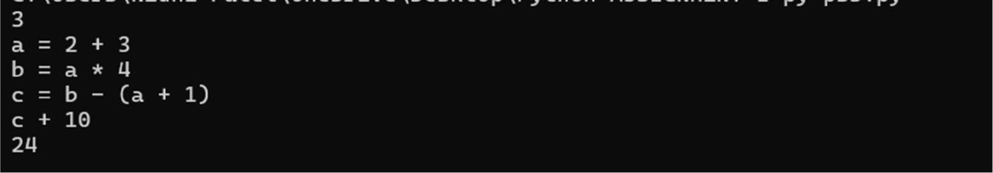

PROBLEM STATEMENT 4: A CSV file contains transaction_id, account_id, type, amount and timestamp. Create a program that reads the file, validates every row, writes valid credit and debit transactions into separate CSV files, writes rejected rows into error.csv with reason, and finally prints account-wise balance changes. The program must continue processing after invalid rows using exception handling.

CODE :
import csv
from datetime import datetime

def validate_transaction(row):
required_fields = ["tid", "acc", "type", "amount", "time"]

for field in required_fields:
if field not in row or not row[field].strip(): return False, f"Missing {field}"
transaction_type = row["type"].strip().upper()

if transaction_type not in ("CREDIT", "DEBIT"): return False, "Invalid transaction type"
try:
amount = float(row["amount"]) except ValueError:
return False, "Amount is not numeric"

if amount <= 0:
return False, "Amount must be greater than zero"

try:
datetime.strptime( row["time"].strip(),
"%Y-%m-%dT%H:%M:%S"
)
except ValueError:
return False, "Invalid timestamp" return True, ""
def

process_file(filename):

balances = {}try:

with open(filename, "r", newline="", encoding="utf-8") as infile: reader = csv.DictReader(infile)
required = {"tid", "acc", "type", "amount", "time"}

if not reader.fieldnames or not required.issubset( set(reader.fieldnames)
):
print("Invalid CSV header.") return
with open(
"credit.csv", "w", newline="", encoding="utf-8"
) as credit_file, \ open(
"debit.csv", "w", newline="", encoding="utf-8"
) as debit_file, \ open(
"error.csv", "w", newline="", encoding="utf-8"
) as error_file:
credit_writer = csv.DictWriter( credit_file, fieldnames=reader.fieldnames
)

debit_writer = csv.DictWriter( debit_file, fieldnames=reader.fieldnames
)
error_fields = reader.fieldnames + ["reason"] error_writer = csv.DictWriter(
error_file, fieldnames=error_fields
)

credit_writer.writeheader() debit_writer.writeheader() error_writer.writeheader()f or row in reader: try:
valid, reason = validate_transaction(row)

if not valid:
row_with_error = row.copy() row_with_error["reason"] = reason error_writer.writerow(row_with_error) continue
account = row["acc"].strip()
transaction_type = row["type"].strip().upper() amount = float(row["amount"])

balances.setdefault(account, 0)
if transaction_type == "CREDIT": credit_writer.writerow(row) balances[account] += amount
else:
debit_writer.writerow(row) balances[account] -= amount
except Exception as error: row_with_error = row.copy() row_with_error["reason"] = str(error) error_writer.writerow(row_with_error
)

except FileNotFoundError: print("Input file not found.") return
except Exception as error: print("Error:", error) return
sorted_balances = sorted( balances.items(),
key=lambda item: abs(item[1]), reverse=True
)

print("Account-wise balance changes:") for account, balance in sorted_balances:
if balance.is_integer(): print(account, int(balance))
else:
print(account, balance)

print("Files created: credit.csv, debit.csv, error.csv") def main():
filename = input("Enter CSV file path: ").strip()

if not filename:
print("File path cannot be empty.") return
process_file(filename) if name == "main":
main()

OUTPUT:
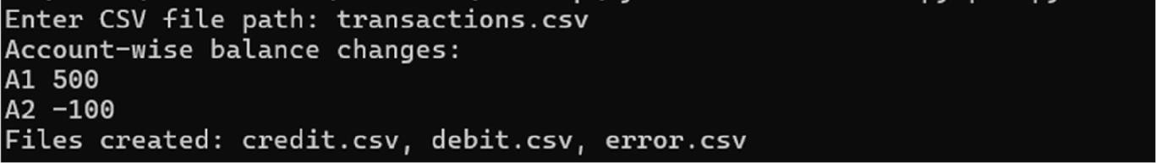

PROBLEM STATEMENT 5: Design an OOP-based settlement engine with Account, Transaction and Bank classes. The engine must support deposit, withdraw and transfer operations, maintain transaction history, prevent overdraft, and rollback an entire batch if any transaction in the batch fails. Use custom exceptions and suitable getters/setters or properties.

CODE :
class BankError(Exception): pass
class
AccountNotFoundError(BankError):
pass
class InvalidAmountError(BankError): pass
class InsufficientBalanceError(BankError): pass
class Account:
def init(self, account_id, balance=0): self.account_id = account_id self._balance = balance self._history = []

@property
def balance(self): return self._balance
def deposit(self, amount): if amount <= 0:
raise InvalidAmountError("Amount must be positive.") self._balance += amount
def withdraw(self, amount): if amount <= 0:
raise InvalidAmountError("Amount must be positive.") if amount > self._balance:
raise InsufficientBalanceError(
f"Insufficient balance in {self.account_id}"
)
self._balance -= amount class Transaction:
def init(self, operation, account_from=None, account_to=None, amount=0):
self.operation = operation self.account_from = account_from

self.account_to = account_to self.amount = amountdef str (self):
return (
f"{self.operation}: "
f"{self.account_from} -> {self.account_to} " f"{self.amount}"
)

class Bank:
def init(self): self.accounts = {} self.history = []
def add_account(self, account_id, balance):
if balance < 0:
raise InvalidAmountError(
"Initial balance cannot be negative."
)
self.accounts[account_id] = Account( account_id,
balance
)
def get_account(self, account_id):
if account_id not in self.accounts: raise AccountNotFoundError(
f"Account {account_id} does not exist."
)

return self.accounts[account_id] def deposit(self, account_id, amount):
account = self.get_account(account_id) account.deposit(amount)
transaction = Transaction( "DEPOSIT",
account_to=account_id, amount=amount
)

self.history.append(transaction)

def withdraw(self, account_id, amount): account = self.get_account(account_id)
account.withdraw(amount) transaction = Transaction(
"WITHDRAW",
account_from=account_id, amount=amount
)

self.history.append(transaction)
def transfer(self, from_id, to_id, amount): source = self.get_account(from_id) destination = self.get_account(to_id) source.withdraw(amount) destination.deposit(amount)

transaction = Transaction( "TRANSFER",
account_from=from_id, account_to=to_id, amount=amount
)
self.history.append(transaction) def snapshot(self):
return {
account_id: account.balance
for account_id, account in self.accounts.items()
}
def restore(self, snapshot):
for account_id, balance in snapshot.items(): self.accounts[account_id]._balance = balance
def main():
bank = Bank()
n = int(input().strip()) for _ in range(n):
account_id, balance = input().split()

bank.add_account( account_id, int(balance))
q = int(input().strip())

batch_number = 0 batch_snapshot = None failed_batches = []
for _ in range(q):
parts = input().split()

if not parts: continue
operation = parts[0]

if operation == "BATCH_BEGIN":

batch_number += 1
batch_snapshot = bank.snapshot() continue
if operation == "BATCH_END": batch_snapshot = None
continue try:
if operation == "DEPOSIT": account_id = parts[1] amount = int(parts[2])
bank.deposit(account_id, amount)

elif operation == "WITHDRAW": account_id = parts[1]
amount = int(parts[2]) bank.withdraw(account_id, amount)
elif operation == "TRANSFER":

from_id = parts[1]

to_id = parts[2]amount = int(parts[3]) bank.transfer( from_id
, to_id, amount
)
else:
raise BankError("Unknown operation.") except BankError:
if batch_snapshot is not None: bank.restore(batch_snapshot) failed_batches.append(batch_number)
while True:
remaining = input().split()
if remaining and remaining[0] == "BATCH_END": break
batch_snapshot = None for number in failed_batches:
print(f"FAILED {number}")
for account_id in sorted(bank.accounts): balance = bank.accounts[account_id].balance print(account_id, balance)
if name == "main": main()

OUTPUT:
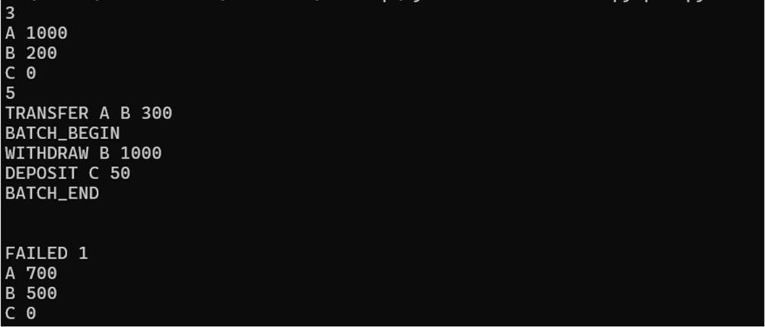

PROBLEM STATEMENT 6: Given a set of Python module names and import relationships, determine a valid loading order. If a circular dependency exists, print CYCLE and the modules involved in one cycle. Ignore duplicate import edges. If multiple modules can be loaded, choose lexicographically smallest module first.

CODE :
import heapq def main():
n, e = map(int, input().split()) modules = []
for _ in range(n): modules.append(input().strip())
adjacency = {
module: [] for module in modules
}
indegree = {
module: 0 for module in modules
}

seen_edges = set() for _ in range(e):
module_a, module_b = input().split() edge = (module_b, module_a)
if edge in seen_edges: continue
seen_edges.add(edge)
adjacency[module_b].append(module_a) indegree[module_a] += 1
heap = []

for module in modules:
if indegree[module] == 0: heapq.heappush(heap,

module)order = [] while heap: current = heapq.heappop(heap) order.append(current)
for dependent in adjacency[current]: indegree[dependent] -= 1
if indegree[dependent] == 0: heapq.heappush(heap, dependent)

if len(order) != n: print("CYCLE")
state = {module: 0 for module in modules} parent = {}
cycle = []
def dfs(node): state[node] = 1
for next_node in adjacency[node]: if state[next_node] == 0:
parent[next_node] = node
if
dfs(next_node)
: return True

elif state[next_node] == 1:

cycle_start = next_node cycle.append(cycle_start) current = node
while current != cycle_start: cycle.append(current) current = parent[current]

cycle.append(cycle_start) cycle.reverse()
return True

state[node] = 2 return False
for module in modules: if state[module] == 0:
if dfs(module): break
print(" ".join(cycle)) else:
print(" ".join(order))
if name == " main ": main()

OUTPUT:
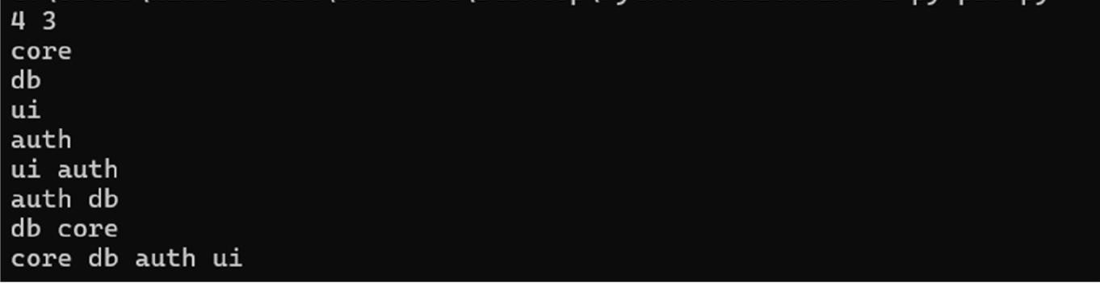

PROBLEM STATEMENT 7: Build an interactive calculator that accepts formulas of the form operand operator operand. Operands may be integers, decimals or previously stored variables. Supported operators are +, -, *, / and %. Invalid format, unknown variables, division by zero and unsupported operators must raise separate custom exceptions. The calculator must continue until the user enters quit.

CODE :
class
InvalidFormatError(Exception): pass
class UnknownVariableError(Exception): pass
class DivisionByZeroError(Exception): pass
class
UnsupportedOperatorError(Exception): pass
def get_operand(value, variables): try:
return float(value) except ValueError:
pass
if value in variables: return variables[value]

raise UnknownVariableError( f"Unknown variable: {value}"
)

def calculate(left, operator, right): if operator == "+":
return left + right

if operator == "-": return left - right

if operator == "*": return left * right
if operator == "/":

if right == 0:
raise DivisionByZeroError( "Cannot divide by zero."
)

return left / right if operator == "%":
if right == 0:
raise DivisionByZeroError( "Cannot use modulo with zero."
)
return left % right
raise UnsupportedOperatorError( f"Unsupported operator: {operator}"
)

def format_result(value): if value.is_integer():
return str(int(value)) return str(value)
def main(): variables = {}
print("Interactive Calculator") print("Enter 'quit' to exit.")
while True: try:
line = input().strip()

if line.lower() == "quit": break

if not line:

raise InvalidFormatError( "Empty input."
)

if "=" in line:
parts = line.split("=") if len(parts) != 2:
raise InvalidFormatError( "Invalid assignment format."
)
variable = parts[0].strip() value_text = parts[1].strip()
if not variable.isidentifier(): raise InvalidFormatError(
"Invalid variable name."
)
if not value_text: raise
InvalidFormatError(
"Missing value."
)

value = get_operand( value_text, variables
)
variables[variable] = value continue
parts = line.split() if len(parts) != 3:
raise InvalidFormatError(
"Formula must be: operand operator operand"
)
left_text, operator, right_text = parts
left = get_operand( left_text, variables
)

right = get_operand(

right_text,variables
)

result = calculate( left,
operator, right
)
print(format_result(result))

except DivisionByZeroError as error: print("DivisionByZeroError") print(error)
except UnsupportedOperatorError: print("UnsupportedOperatorError")

except UnknownVariableError as error: print("UnknownVariableError") print(error)

except InvalidFormatError as error: print("InvalidFormatError"
) print(error)
if name== "main": main()

OUTPUT:
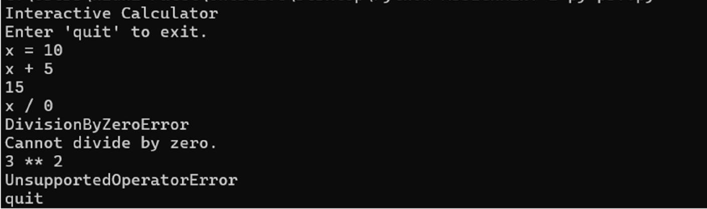

PROBLEM STATEMENT 8: A server produces several text log files. Create a program that scans all files in a folder, builds an inverted index mapping each normalized token to the list of file names and line numbers where it appears, stores the index using pickle, and compresses both original logs and index into a zip file. The program must also support a search mode that loads the pickle index and answers token queries.

CODE :
import os import re import pickle import zipfile
TOKEN_PATTERN = re.compile(r"[A-Za-z0-9_]+") def tokenize(line):
return [
token.lower()
for token in TOKEN_PATTERN.findall(line)
]
def build_index(folder_path, zip_name): if not os.path.isdir(folder_path):
print("Invalid folder path.") return
index = {}

total_files = 0
total_lines = 0
for filename in os.listdir(folder_path): full_path = os.path.join(
folder_path, filename
)
if not os.path.isfile(full_path): continue
total_files += 1 try:

with open( full_path, "r",
encoding="utf-8", errors="ignore"
) as file:

for line_number, line in enumerate( file,
start=1
):

total_lines += 1

tokens = tokenize(line) for token in set(tokens):

if token not in index: index[token] = []

index[token].append( (filename, line_number)
)

except
OSError: continue

pickle_path = os.path.join( folder_path,
"index.pkl"
)
with open(pickle_path, "wb") as file: pickle.dump(index, file)

with zipfile.ZipFile( zip_name,
"w",
zipfile.ZIP_DEFLATED
) as archive:
for filename in os.listdir(folder_path): full_path = os.path.join(

folder_path, filename
)

if os.path.isfile(full_path):

if os.path.abspath(full_path) == os.path.abspath( zip_name
):
continue
archive.write( full_path, arcname=filename
)
print(f"FILES {total_files}") print(f"LINES {total_lines}") print(f"TOKENS {len(index)}")
def search_index(pickle_path, queries): try:
with open(pickle_path, "rb") as file: index = pickle.load(file)

except FileNotFoundError: print("Pickle index not found.") return

for query in queries: token = query.lower()
matches = index.get(token, []) print(f"{token}:")
for filename, line_number in matches: print(f"{filename}:{line_number}")
def main():
mode = input().strip().upper() if mode == "BUILD":
parts = input().split() if len(parts) != 2:

print("Invalid BUILD format.")return
folder_path = parts[0] zip_name = parts[1]

build_index( folder_path, zip_name
)
elif mode == "SEARCH": parts = input().split()

if len(parts) < 2:
print("Invalid SEARCH format.") return
pickle_path = parts[0] q = int(parts[1]) queries = []
for _ in range(q): queries.append(input().strip())
search_index( pickle_path, queries
)
else:
print("Invalid mode. Use BUILD or SEARCH.") if name == "main":
main()

OUTPUT:
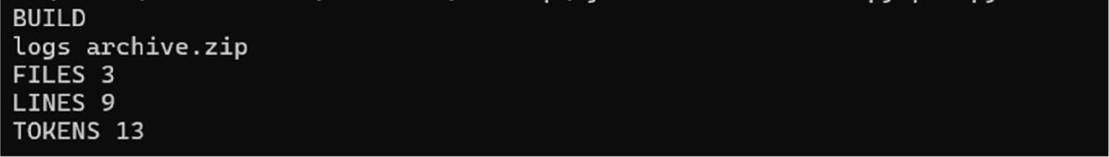

PROBLEM STATEMENT 9: Simulate a job scheduler where each job has job_id, priority, duration and required resource count. Multiple worker threads execute jobs. Higher priority jobs must be processed first; jobs with same priority use earlier arrival order. The program must maintain thread-safe job assignment and produce a final execution report.

CODE :
import heapq import threading
from dataclasses import dataclass @dataclass
class Job: arrival: int job_id: str priority: int duration: int resources: int order: int
def simulate(jobs, worker_count):
jobs.sort( key=lambda job: (
job.arrival, job.order
)
)
waiting = [] workers = [ (0, i + 1)
for i in range(worker_count)
]
heapq.heapify(workers) results = []
index = 0
current_time = 0
while index < len(jobs) or waiting:
if not waiting and index < len(jobs): current_time = max(
current_time, jobs[index].arrival
)

while (

index < len(jobs)and jobs[index].arrival <= current_time
):
job = jobs[index] heapq.heappush(
waiting, (
-job.priority, job.arrival, job.order, job
)
)

index += 1
finish_time, worker_id = heapq.heappop( workers
)
current_time = max( current_time, finish_time
)
while (
index < len(jobs)
and jobs[index].arrival <= current_time
):
job = jobs[index] heapq.heappush(
waiting, (
-job.priority, job.arrival, job.order, job
)
)

index += 1 if not waiting:
heapq.heappush( workers,
(current_time, worker_id)
)

continue
_, _, _, job = heapq.heappop(waiting)

start_time = max( current_time, job.arrival, finish_time
)
finish_time = ( start_time
+
job.duration
)

waiting_time = ( start_time - job.arrival
)
results.append( (
job.job_id, worker_id, start_time, finish_time, waiting_time
)
)

heapq.heappush( workers,
(
finish_time, worker_id
)
)
current_time = start_time return results
def main():
w, n = map(int, input().split()) if not (1 <= w <= 64):
raise ValueError("Workers must be between 1 and 64.")

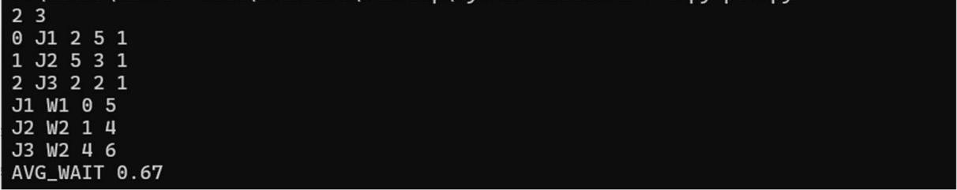
jobs = []
for order in range(n):
arrival, job_id, priority, duration, resources = (input().split()
)
job = Job( int(arrival), job_id, int(priority), int(duration), int(resources), order
)
jobs.append(job) results = simulate(
jobs, w
)
total_wait = sum( result[4]
for result in results
)
for job_id, worker_id, start, finish, wait in results: print(
f"{job_id} W{worker_id} " f"{start} {finish}"
)
average_wait = ( total_wait / len(results) if results
else 0
)
print(
f"AVG_WAIT {average_wait:.2f}"
)
if name == "main": main()

OUTPUT:

PROBLEM STATEMENT 10: Create a Tkinter GUI application to manage student assignment submissions. The application must support adding a student, adding a submission, updating marks, filtering by pending/completed status, and exporting a CSV report. Data must persist locally using JSON or CSV files. Input fields must be validated before saving.

CODE :
import tkinter as tk
from tkinter import ttk, messagebox, filedialog import json
import csv import os
DATA_FILE = "assignments.json" class AssignmentTracker:
def init(self, root):

self.root = root self.root.title("Assignment Tracker") self.root.geometry("900x600")
self.records = self.load_data() self.create_widgets()

self.refresh_table() def load_data(self):
if not os.path.exists(DATA_FILE): return []

try:
with open( DATA_FILE, "r",
encoding="utf-8"
) as file:

return json.load(file)

except (json.JSONDecodeError, OSError):

return []
def save_data(self): with open(
DATA_FILE, "w",
encoding="utf-8"
) as file:

json.dump( self.records, file, indent=4
)
def create_widgets(self): title = tk.Label(
self.root,
text="Student Assignment Tracker", font=("Arial", 18, "bold")
)
title.pack(pady=10)

input_frame = tk.Frame(self.root) input_frame.pack(pady=5)

tk.Label( input_frame, text="Enrollment:"
).grid(row=0, column=0, padx=5)

self.enrollment_entry = tk.Entry( input_frame
)
self.enrollment_entry.grid( row=0,
column=1, padx=5
)
tk.Label(

input_frame, text="Name:"
).grid(row=0, column=2, padx=5)

self.name_entry = tk.Entry( input_frame
)
self.name_entry.grid( row=0,
column=3, padx=5
)

tk.Label( input_frame, text="Assignment:
"
).grid(row=1, column=0, padx=5)

self.assignment_entry = tk.Entry( input_frame
)
self.assignment_entry.grid( row=1,
column=1, padx=5
)

tk.Label( input_frame, text="Status:"
).grid(row=1, column=2, padx=5)

self.status_combo = ttk.Combobox( input_frame,
values=["Pending", "Completed"], state="readonly"
)
self.status_combo.set("Pending")

self.status_combo.grid(

row=1,column=3, padx=5
)

tk.Label( input_frame, text="Marks:"
).grid(row=2, column=0, padx=5)

self.marks_entry = tk.Entry( input_frame
)
self.marks_entry.grid( row=2,
column=1, padx=5
)

tk.Label( input_frame, text="Remarks:"
).grid(row=2, column=2, padx=5)

self.remarks_entry = tk.Entry( input_frame
)

self.remarks_entry.grid( row=2,
column=3, padx=5
)

button_frame = tk.Frame(self.root) button_frame.pack(pady=10)

tk.Button( button_frame,
text="Add Submission", command=self.add_submission
).grid(row=0, column=0, padx=5)

tk.Button(

button_frame, text="Update Marks",
command=self.update_marks
).grid(row=0, column=1, padx=5)

tk.Button( button_frame, text="Export CSV",
command=self.export_csv
).grid(row=0, column=2, padx=5)
tk.Button( button_frame, text="Clear",
command=self.clear_fields
).grid(row=0, column=3, padx=5)

filter_frame = tk.Frame(self.root) filter_frame.pack(pady=5)

tk.Label( filter_frame, text="Filter:"
).pack(side=tk.LEFT)

self.filter_combo = ttk.Combobox( filter_frame,
values=[ "All", "Pending",
"Completed"
],
state="readonly"
)
self.filter_combo.set("All") self.filter_combo.pack(
side=tk.LEFT, padx=5
)

OUTPUT:
